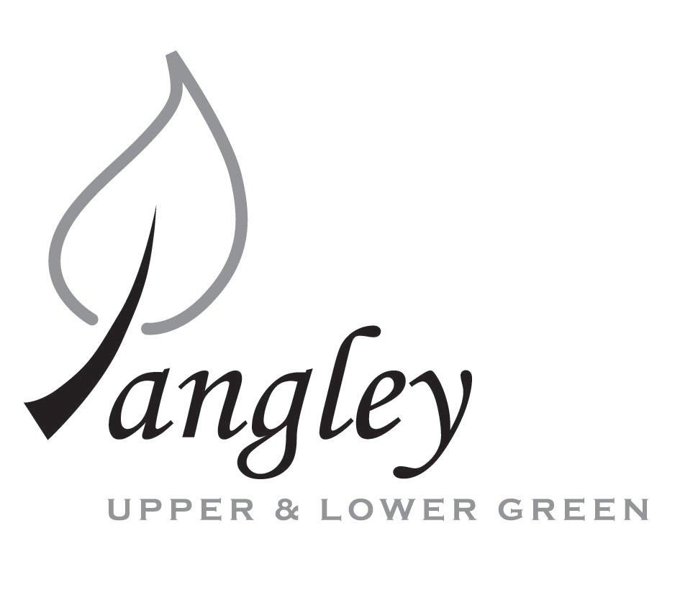
13 Princes Close, Balsham, Cambridgeshire CB21 4EE
E-mail: langleyclerk@googlemail.com
Telephone: 07539 249852

COUNCILLORS ARE SUMMONED TO ATTEND A MEETING OF LANGLEY PARISH COUNCIL
HELD VIRTUALLY VIA ZOOM ON
MONDAY 14th September 2020 at 8.00pm
THE PRESS AND THE PUBLIC ARE CORDIALLY INVITED TO ATTEND – please email Clerk for log-in details

MEETING WILL BE RECORDED VIA ZOOM and HAVE A 40 MINUTE DURATION

AGENDA URGENT ITEMS ONLY
This Parish Council supports the rights of anyone to record this meeting but advises that anyone so recording cannot disrupt the meeting, by means of the recording and expresses the hope that the person (or persons) carrying out the recording has obtained the necessary legal advice, for themselves, to ensure they understand the rights of any members of the public who may be present who do not wish to be filmed or recorded.

1. APOLOGIES FOR ABSENCE
1.1 To receive apologies for absence.

2. DECLARATION OF INTERESTS
2.1 To declare any disclosable pecuniary, other pecuniary or non-pecuniary interests relating to items on the agenda.

3. PUBLIC PARTICIPATION SESSION WITH RESPECT TO ITEMS ON THE AGENDA AND OTHER MATTERS THAT ARE OF MUTUAL INTEREST
3.1 The maximum time allowed for this item is 15 minutes. Members of the public who wish to comment on an Agenda item should do so at this point – maximum time allowed 5 minutes per Agenda item. Any questions raised shall not require a response at the meeting nor start a debate on the question. The Chair of the meeting may direct that a written or oral response be given.

4. MINUTES OF THE LAST MEETING
4.1 Councilors are asked to agree the Minutes of the Parish Council meeting held on Monday 13th July and the extraordinary Parish Council meeting held on Monday 10th August as a true and accurate account of the proceedings of the meetings.

6. FINANCIAL
6.1 Financial Report – Bank reconciliation as at 21st August, the current account balance was £13,325.83. PC unpresented cheques, £1,133.23 resulting in a current account balance of £12,192.60. Broken down as follows: Playground funds £1,230.48; Highways Devolution Project £1,000, PC funds £9,962.12. PC deposit account £4,521.60 – reserves unrestricted of £521.60 and reserves restricted (playground fund) of £4,000. Please note the uplift in the balance of the current account and the low amount in the deposit account is due to a bank transfer from the deposit account of £8,627.96 into the current account. This was agreed by all Councillors during July PC meeting.
6.2 Review of Cheque Run
6.3 Cheque included for £33 to Deborah Haines following a bank transfer made in error.
6.4 VAT Return
6.5 Highways Devolution Agreement

7. PLANNING APPLICATIONS/PROPERTY
None received.

8. LANGLEY VILLAGE PROJECT
8.1 Brief update from Village Project representatives.

9. VILLAGE GREEN
9.1 New village noticeboard for Lower Green
9.2 Request from LCC&ST to use the Green for car boot sale on Sunday 11th October.

10. LOCAL ENVIRONMENT
10.1 Affinity Water complaint letter
10.4 Highways pothole repair status
10.5 Bull Lane ditch
10.6 Grass cutting replacement for Hugh Law for the remainder of this season before new tender goes out in March.
10.7 UDC Tree Planting Initiative
10.8 Phone Box in Lower Green
10.9 Flooding issue for Butimber/Ashwater
10.10 Gigaclear / Letter to SuperFast Essex
10.11 Great Crested Newts Fencing

11. PLAYGROUND

12. DISTRICT AND COUNTY COUNCIL
12.1 Cllr. Oliver to provide District Council report.

13. CHEQUES FOR SIGNING
13.1 Council to agree to the following cheques to be signed:
Langley Parish Council - Cheque run for September 2020
Deborah Haines | Reimbursement after Bank Transfer sent in error | 101419 | £33.00
Erica Williams | Clerks Salary (including monthly Zoom cost) | 101420 | £374.19
 |  | Total: | £407.19

14. MATTERS TO BE RAISED BY MEMBERS FOR THE NEXT AGENDA
14.1 Please note that no decisions can lawfully be made under this item. LGA 1972, Section 12 10(2)(b) states that business must be specified; therefore, the Council cannot lawfully raise matters for decision.

15. DATE OF NEXT MEETINGS
15.1 The next meeting will be on Monday 12th October 2020

SIGNED (CLERK): | DATE:

