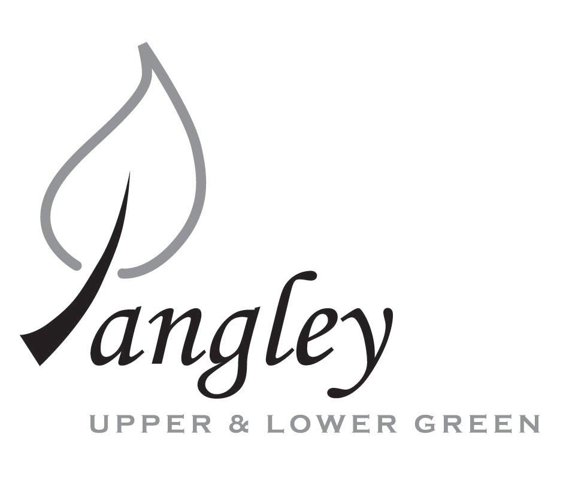
13 Princes Close, Balsham, Cambridgeshire CB21 4EE
E-mail: langleyclerk@googlemail.com
Telephone: 07539 249852

COUNCILLORS ARE SUMMONED TO ATTEND A MEETING OF LANGLEY PARISH COUNCIL
HELD VIRTUALLY VIA ZOOM ON
MONDAY 13th July 2020 at 8.00pm
THE PRESS AND THE PUBLIC ARE CORDIALLY INVITED TO ATTEND – please email Clerk for log-in details

MEETING WILL BE RECORDED VIA ZOOM and HAVE A 40 MINUTE DURATION

AGENDA URGENT ITEMS ONLY
This Parish Council supports the rights of anyone to record this meeting but advises that anyone so recording cannot disrupt the meeting, by means of the recording and expresses the hope that the person (or persons) carrying out the recording has obtained the necessary legal advice, for themselves, to ensure they understand the rights of any members of the public who may be present who do not wish to be filmed or recorded.

1. APOLOGIES FOR ABSENCE
1.1 To receive apologies for absence.

2. DECLARATION OF INTERESTS
2.1 To declare any disclosable pecuniary, other pecuniary or non-pecuniary interests relating to items on the agenda.

3. PUBLIC PARTICIPATION SESSION WITH RESPECT TO ITEMS ON THE AGENDA AND OTHER MATTERS THAT ARE OF MUTUAL INTEREST
3.1 The maximum time allowed for this item is 15 minutes. Members of the public who wish to comment on an Agenda item should do so at this point – maximum time allowed 5 minutes per Agenda item. Any questions raised shall not require a response at the meeting nor start a debate on the question. The Chair of the meeting may direct that a written or oral response be given.

4. MINUTES OF THE LAST MEETING
4.1 Councilors are asked to agree the Minutes of the Parish Council meeting held on Monday 8th June as a true and accurate account of the proceedings of the meetings.

6. FINANCIAL
6.1 Financial Report – Bank reconciliation as at 23rd June, the current account balance was £12,573.28. PC unpresented cheques, £1,374.86 resulting in a current account balance of £11,198.42. Broken down as follows: Playground funds £1,230.48; Highways Devolution Project £1,000, PC funds £8,967.94. PC deposit account £13,149.56 (interest of £3.53) – reserves unrestricted of £9,149.56 and reserves restricted (playground fund) of £4,000.
6.2 Review of Cheque Run
6.3 Transfer of money from unrestricted reserves back into contingencies for Community Centre grant.
Annual Return
Items 6.4 – 6.11 presented to the Council by Jane Kidd
6.4 Year-end accounts (ending 31st March 2020), including Bank Reconciliation, Receipts and Payments and Analysis of Variances to be approved by Council and signed by Chair.
6.5 Internal Control Statement for Year Ending 31st March 2020. To be approved by Council and signed by Chair.
6.6 Financial & Management Risk Assessment last reviewed in June 2019; to be reviewed again in May 2021.
6.7 As neither the gross income nor gross expenditure exceeds £25,000 the PC are exempt from an external audit/limited assurance review; Certificate of Exemption to be approved, dated and signed by RFO and Chair. Signed document to be submitted to PFK Littlejohns by 31st July 2020 together with completed contact details form.
6.8 Results of Internal Audit to be reported to PC.
6.9 Council to review and approve by resolution the Annual Governance Statement 2019/2020 signed and dated by RFO and Chair.
6.10 Council to review and approve by resolution the Accounting Statements 2019/2020 signed and dated by RFO and Chair.
6.11 Copies of the following documents to be published on website by 1st September 2020
a) the completed certificate of exemption;
b) the completed, signed and dated annual internal audit report;
c) the completed, approved, dated and signed annual governance statement;
d) the completed, approved, dated and signed summary accounting statements;
e) an analysis of variances
f) a bank reconciliation;
g) notice of the period for the exercise of public rights; (This year there is no requirement for a common period for the exercise of public rights. However, smaller authorities are still required to set a period for this purpose, but the only requirement is that the 30-working day period for the exercise of public rights should start on or before the first working day of September. Dates set as Tuesday 1st September to Monday 12th October. Notice to be published on website and noticeboards on Friday 28th August 2020.

7. PLANNING APPLICATIONS/PROPERTY
7.1 UTT/20/1583/OP 1 and 2 Grange Cottages, Upper Green Road, Upper Green CB11 4RY

8. LANGLEY VILLAGE PROJECT
8.1 Brief update from Village Project representatives.

9. VILLAGE GREEN
9.1 New village noticeboard

10. LOCAL ENVIRONMENT
10.1 Affinity Water complaint letter
10.2 Footpath Systems maintenance request from Peter Balaam
10.3 Gigaclear latest update
10.4 Highways pothole repair status

11. PLAYGROUND
11.1 Playground inspection report from ROSPA
11.2 Current status of new playground installation

12. DISTRICT AND COUNTY COUNCIL
12.1 Cllr. Oliver to provide District Council report.

13. CHEQUES FOR SIGNING
13.1 Council to agree to the following cheques to be signed:
Langley Parish Council - Cheque run for July 2020
Playsafety Ltd (ROSPA) | Playground Inspection | 101407 | £107.40
SB Printing | Langley Village Voice printing | 101408 | £50.00
Jane Kidd | Preparation of Year End accounts | 101409 | £100.00
RCCE | Renewal of membership | 101410 | £52.80
Erica Williams | Clerks Salary | 101411 | £299.68
Cllr North | Reimbursement – COVID supplies for playground | 101412 | £117.94
 |  | Total: | £727.82

14. MATTERS TO BE RAISED BY MEMBERS FOR THE NEXT AGENDA
14.1 Please note that no decisions can lawfully be made under this item. LGA 1972, Section 12 10(2)(b) states that business must be specified; therefore, the Council cannot lawfully raise matters for decision.

15. DATE OF NEXT MEETINGS
15.1 The next meeting will be on Monday 14th September 2020 (Please note there is no meeting during August)

SIGNED (CLERK): | DATE:

