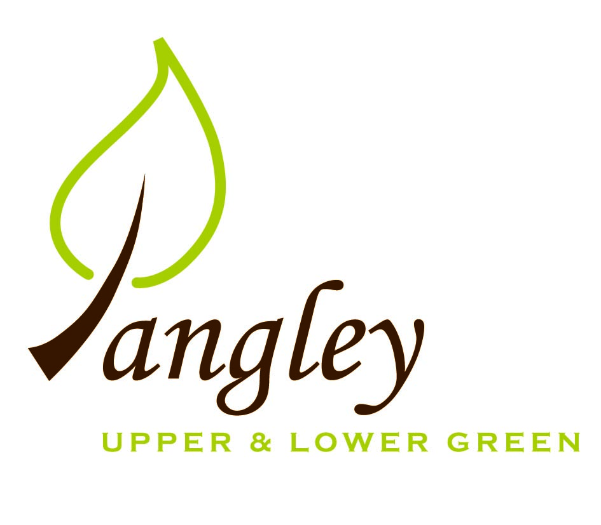
Langley Parish Council
Clerk: Erica Williams
13 Princes Close, Balsham, Cambridge CB21 4EE
07539 249852
langleyclerk@googlemail.com

A quick update from Langley Parish Council on work being carried out alongside Essex Highways to alleviate flooding issues in Langley Lower Green:
Over recent months, multiple ditches have been cleared and jetting work to clear blocked culverts has been carried out in various locations. Essex Highways are addressing the two particularly large potholes in Lower Langley (outside Straws and CobblersMead) and have just escalated this work to commence much earlier than originally planned, so now may start this week commencing 7th April 2025.
There are two live links available to track live Highways closures; https://www.essexhighways.org/live-traffic-map and https://one.network/public (please note that the new date for planned pothole work has not yet updated on these portals).
Additional items EH will be addressing in the coming weeks include a blocked/overflowing gulley on Bull Lane (outside Rouen) and a culvert leading to The Stort (outside Hurdles) that needs re-piping, timescales yet to be confirmed.
Flood management is an ongoing project that will continue in stages - to keep everyone posted on this work, moving forwards LPC will provide progress updates on our website noticeboard, we hope this will be useful for all and please do also feel free to review any Parish Council meeting minutes on our website , village noticeboards and of course all are very welcome to join the monthly PC meeting in Langley Community Centre of the 2nd Monday of each month.

