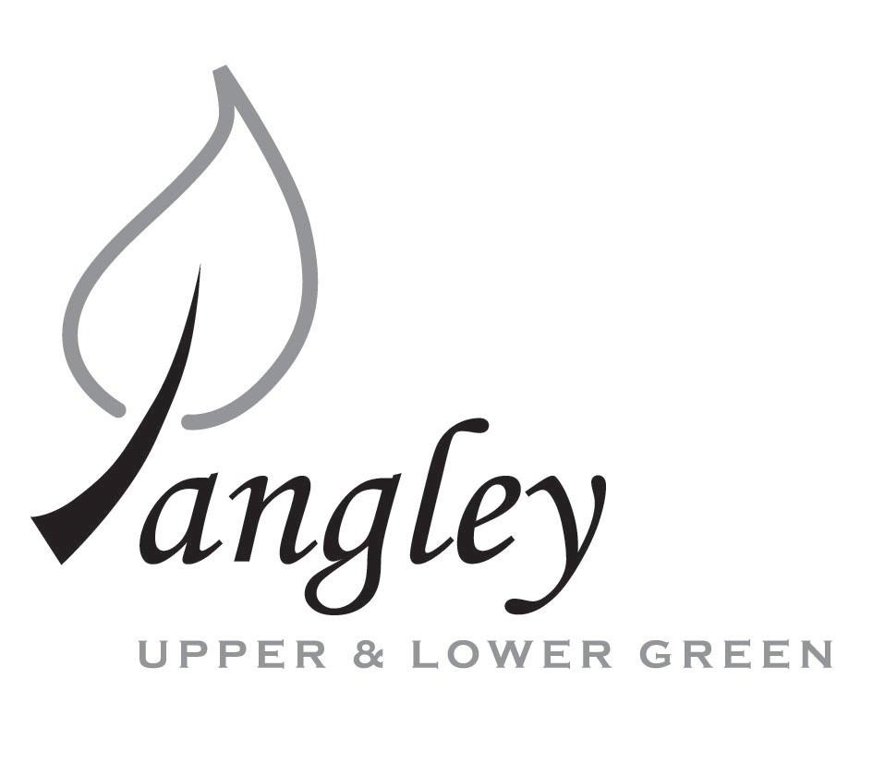
13 Princes Close, Balsham, Cambridgeshire CB21 4EE
E-mail: langleyclerk@googlemail.com
Telephone: 07539 249852

COUNCILLORS ARE SUMMONED TO ATTEND A MEETING OF LANGLEY PARISH COUNCIL
HELD AT LANGLEY COMMUNITY CENTRE ON
Monday 12th June 2023 at 8.00pm
THE PRESS AND THE PUBLIC ARE CORDIALLY INVITED TO ATTEND

This Parish Council supports the rights of anyone to record this meeting but advises that anyone so recording cannot disrupt the meeting, by means of the recording and expresses the hope that the person (or persons) carrying out the recording has obtained the necessary legal advice, for themselves, to ensure they understand the rights of any members of the public who may be present who do not wish to be filmed or recorded.

1. APOLOGIES FOR ABSENCE
1.1 To receive apologies for absence. Apologies received from Cllrs North and Smith in advance of the meeting.

2. DECLARATION OF INTERESTS
2.1 To declare any disclosable pecuniary, other pecuniary or non-pecuniary interests relating to items on the agenda.

3. PUBLIC PARTICIPATION SESSION WITH RESPECT TO ITEMS ON THE AGENDA AND OTHER MATTERS THAT ARE OF MUTUAL INTEREST
3.1 The maximum time allowed for this item is 15 minutes. Members of the public who wish to comment on an Agenda item should do so at this point – maximum time allowed 5 minutes per Agenda item. Any questions raised shall not require a response at the meeting nor start a debate on the question. The Chair of the meeting may direct that a written or oral response be given.

4. MINUTES OF THE LAST MEETING
4.1 Councillors are asked to agree the Minutes of the Parish Council meetings held on Wednesday 10th May 2023, as a true and accurate account of the proceedings of the meetings.

6. FINANCIAL
6.1 Financial Report – Bank reconciliation as at 31st May, the current account balance was £26,507.47. PC unpresented payments, £2,290.92 resulting in a current account balance of £24,216.55. Broken down as follows: Playground H&S funds £3,000.00, Ditches funds £2,000.00, Playground funds £3,214.14; PC funds £16,002.41. PC deposit account £10,109.15.
6.2 Review of BACS payments.
6.3 Quote for playground repairs/maintenance
Items 6.4 – 6.12 presented to the Council by Jane Kidd
6.4 Year-end accounts (ending 31st March 2023), including Bank Reconciliation, Receipts and Payments and Analysis of Variances to be approved by Council and signed by Chair.
6.5 Internal Control Statement for Year Ending 31st March 2023. To be approved by Council and signed by Chair.
6.6 Financial & Management Risk Assessment last reviewed in May 2022 to be reviewed again in May 2023.
6.7 As neither the gross income nor gross expenditure exceeds £25,000 the PC are exempt from an external audit/limited assurance review;
6.8 Certificate of Exemption to be approved, dated and signed by RFO and Chair. Signed document to be submitted to PFK Littlejohns ASAP together with completed contact details form.
6.9 Results of Internal Audit to be reported to PC.
6.10 Council to review and approve by resolution the Annual Governance Statement 2022/2023 signed and dated by RFO and Chair.
6.11 Council to review and approve by resolution the Accounting Statements 2022/2023 signed and dated by RFO and Chair.
6.12 Copies of the following documents to be published on website on Monday 19th June 2023.
a) completed certificate of exemption;
b) completed, signed and dated annual internal audit report;
c) completed, approved, dated and signed annual governance statement;
d) completed, approved, dated and signed summary accounting statements;
e) analysis of variances
f) bank reconciliation;
g) notice of the period for the exercise of public rights; Dates set as Monday 19th June to Friday 28th July. Notice to be published on website and noticeboards on Friday 16th June 2023.

7. PLANNING APPLICATIONS/PROPERTY
7.1 Applications:
UTT/23/1243/HHF Herons Rest, Upper Green Road
UTT/23/1216/HHF Duddenhoe Grange, Upper Green Road
UTT/23/1399/FUL Langley Lawn, Langley Lower Green

8. LANGLEY VILLAGE PROJECT
8.1 Brief update from Village Project representatives.

10. LOCAL ENVIRONMENT
10.1 Trees / Verges / Grass cutting / Ditches
10.2 UDC Parish Planning training
10.3 Rural Affordable housing
10.4 Identify possible community projects
10.5 Hire of community centre for events
10.6 Salt bag partnership scheme

11. PLAYGROUND
11.1 Playground update
11.2 Playground maintenance

12. DISTRICT AND COUNTY COUNCIL
12.1 Cllr. Oliver to provide District Council report.

13. BACS PAYMENTS
13.1 Council to agree to the following BACS payments to be made:
Langley Parish Council – BACS payments for June 2023
Sue Smith | Reimbursement for Coronation costs (paid prior to meeting) |  | £48.03
BHIB | Parish Council insurance renewal |  | £467.67
Erica Williams | Clerks salary |  | £443.05
UK Power Networks | Disconnection of electricity supply |  | £991.20
 |  | Total | £1,949.95

14. MATTERS TO BE RAISED BY MEMBERS FOR THE NEXT AGENDA
14.1 Please note that no decisions can lawfully be made under this item. LGA 1972, Section 12 10(2)(b) states that business must be specified; therefore, the Council cannot lawfully raise matters for decision.

15. DATE OF NEXT MEETINGS
15.1 The next meeting will be on Monday 10th July 2023 in Langley Community Centre.

SIGNED (CLERK): | DATE:

