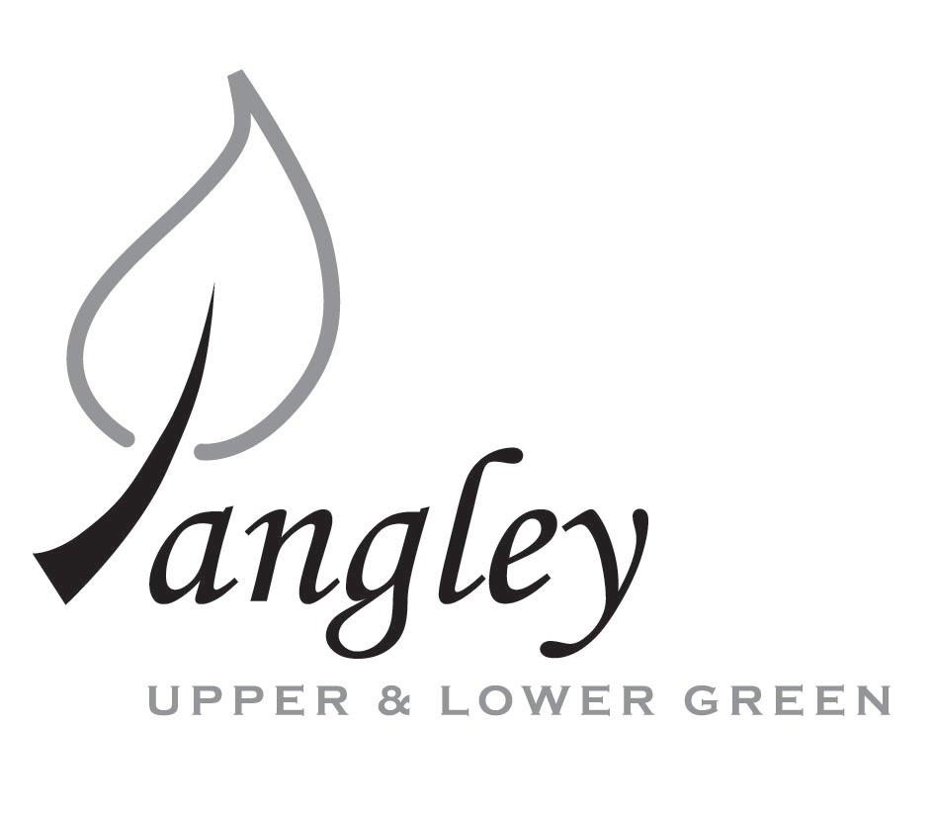
13 Princes Close, Balsham, Cambridgeshire CB21 4EE
E-mail: langleyclerk@googlemail.com
Telephone: 07539 249852

COUNCILLORS ARE SUMMONED TO ATTEND A MEETING OF LANGLEY PARISH COUNCIL
HELD AT LANGLEY COMMUNITY CENTRE ON
TUESDAY 11th April 2023 at 8.00pm
THE PRESS AND THE PUBLIC ARE CORDIALLY INVITED TO ATTEND

This Parish Council supports the rights of anyone to record this meeting but advises that anyone so recording cannot disrupt the meeting, by means of the recording and expresses the hope that the person (or persons) carrying out the recording has obtained the necessary legal advice, for themselves, to ensure they understand the rights of any members of the public who may be present who do not wish to be filmed or recorded.

1. APOLOGIES FOR ABSENCE
1.1 To receive apologies for absence.

2. DECLARATION OF INTERESTS
2.1 To declare any disclosable pecuniary, other pecuniary or non-pecuniary interests relating to items on the agenda.

3. PUBLIC PARTICIPATION SESSION WITH RESPECT TO ITEMS ON THE AGENDA AND OTHER MATTERS THAT ARE OF MUTUAL INTEREST
3.1 The maximum time allowed for this item is 15 minutes. Members of the public who wish to comment on an Agenda item should do so at this point – maximum time allowed 5 minutes per Agenda item. Any questions raised shall not require a response at the meeting nor start a debate on the question. The Chair of the meeting may direct that a written or oral response be given.

4. MINUTES OF THE LAST MEETING
4.1 Councillors are asked to agree the Minutes of the Parish Council meetings held on Monday 13th March 2023, as a true and accurate account of the proceedings of the meetings.

6. FINANCIAL
6.1 Financial Report – Bank reconciliation as at 31st March, the current account balance was £18,747.85. PC unpresented payments, £732.64 resulting in a current account balance of £18,015.21. Broken down as follows: Playground H&S funds £3,000.00, Ditches funds £2,000.00, Playground funds £2,305.52; PC funds £10,709.69. PC deposit account £10,109.15.
6.2 Review of BACS payments.
6.4 Permission required to engage JK Bookkeeping and independent Auditor for Year End Accounts.

7. PLANNING APPLICATIONS/PROPERTY
7.1 Decisions:
UTT/23/0077/HHF – 1 The Kangels, Langley Upper Green – AWAITING DECISION
UTT/22/0997/HHF – Fleet Cottage – APPEAL DISMISSED
UTT/23/0420/FUL (and LB) – The Bull, Langley Lower Green
7.2 Applications:
UTT/23/0650/HHF – New Farm, Waterwick Hill

8. LANGLEY VILLAGE PROJECT
8.1 Brief update from Village Project representatives.

10. LOCAL ENVIRONMENT
10.1 Trees / Verges / Grass cutting / Ditches
10.2 Safety on the Village Green
10.3 Defib status
10.4 Coronation
10.5 Local elections 2023

10.6 Attendance at May meeting
10.7 Permission to conduct Fete on the Village Green
10.8 Deed of Grant requested by parishioner to formalise current access to their land
10.9 Concern from parishioner regarding possible scam website
10.10 Hundred Parishes Society grant funding

11. PLAYGROUND
11.1 Playground update

12. DISTRICT AND COUNTY COUNCIL
12.1 Cllr. Oliver to provide District Council report.

13. BACS PAYMENTS
13.1 Council to agree to the following BACS payments to be made:
Langley Parish Council – BACS payments for April 2023
Sovereign Design & Play Safety | Installation of new playground equipment (paid in March) |  | £1090.34
Erica Williams | Clerks salary |  | £343.64
 |  | Total | £1,433.98

14. MATTERS TO BE RAISED BY MEMBERS FOR THE NEXT AGENDA
14.1 Please note that no decisions can lawfully be made under this item. LGA 1972, Section 12 10(2)(b) states that business must be specified; therefore, the Council cannot lawfully raise matters for decision.

15. DATE OF NEXT MEETINGS
15.1 The next meeting will be on Wednesday 10th May 2023 in Langley Community Centre.

SIGNED (CLERK): | DATE:

