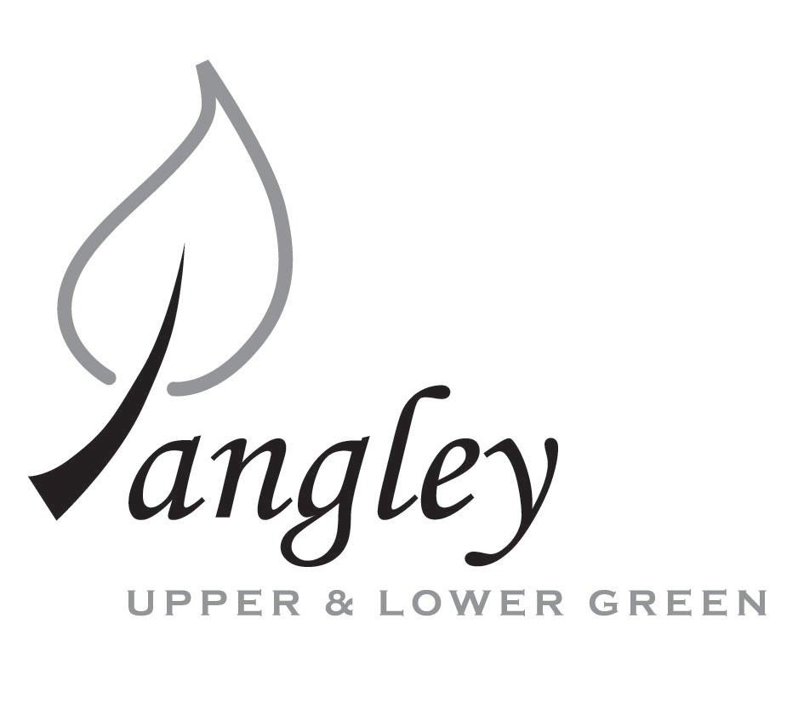
13 Princes Close, Balsham, Cambridgeshire CB21 4EE
E-mail: langleyclerk@googlemail.com
Telephone: 07539 249852

COUNCILLORS ARE SUMMONED TO ATTEND A MEETING OF LANGLEY PARISH COUNCIL
HELD AT LANGLEY COMMUNITY CENTRE ON
Monday 13th May 2024 at 8.00pm
THE PRESS AND THE PUBLIC ARE CORDIALLY INVITED TO ATTEND

This Parish Council supports the rights of anyone to record this meeting but advises that anyone so recording cannot disrupt the meeting, by means of the recording and expresses the hope that the person (or persons) carrying out the recording has obtained the necessary legal advice, for themselves, to ensure they understand the rights of any members of the public who may be present who do not wish to be filmed or recorded.

1. APOLOGIES FOR ABSENCE
1.1 To receive apologies for absence.

2. DECLARATION OF INTERESTS
2.1 To declare any disclosable pecuniary, other pecuniary or non-pecuniary interests relating to items on the agenda.

3. PUBLIC PARTICIPATION SESSION WITH RESPECT TO ITEMS ON THE AGENDA AND OTHER MATTERS THAT ARE OF MUTUAL INTEREST
3.1 The maximum time allowed for this item is 15 minutes. Members of the public who wish to comment on an Agenda item should do so at this point – maximum time allowed 5 minutes per Agenda item. Any questions raised shall not require a response at the meeting nor start a debate on the question. The Chair of the meeting may direct that a written or oral response be given.

4. MINUTES OF THE LAST MEETING
4.1 Councillors are asked to agree the Minutes of the Parish Council meeting held on Monday 8th April 2024, as a true and accurate account of the proceedings of the meetings.

5. FINANCIAL
5.1 Financial Report – Bank reconciliation as at 30th April, the current account balance was £22,583.78 (1st precept payment received of £8,500.00). PC unpresented payments, £519.44 resulting in a current account balance of £22,064.34. Broken down as follows: Playground H&S funds £699.37, Ditches funds £2,000.00, Playground funds £3,214.14; PC funds £16,150.83. PC deposit account £10,376.73.
5.2 Review of BACS payments.
5.3 Parish Council insurance renewal

6. PLANNING APPLICATIONS/PROPERTY
6.1 UTT/24/1037/FUL – Laburnham House, Langley Upper Green
6.2 UTT/23/0915/FUL (Planning appeal) – Hall Farm, Langley Upper Green

7. LANGLEY VILLAGE PROJECT
7.1 Brief update from Village Project representatives.

8. LOCAL ENVIRONMENT
8.1 Grass cutting schedule
8.2 Update on revised ditch clearance programme and flooding
8.3 Flashing speed signs update
8.4 Rural Affordable Housing next steps
8.5 D-Day celebrations and Beacon event
8.6 Cllr training dates
8.7 Community Awards
8.8 Annual Village Meeting - 22nd May 2024
8.9 Track at the top of the Green

9. PLAYGROUND
9.1 Playground maintenance to include quote received for tree / bush works.

10. DISTRICT AND COUNTY COUNCIL
10.1 Cllr. Oliver to provide District Council report.

11. BACS PAYMENTS
11.1 Council to agree to the following BACS payments to be made:
Langley Parish Council – BACS payments for May 2024
London Hearts | Replacement defibrillator pads |  | £56.40
Sustainable Furniture | New bench for the Village Green (paid in April) |  | £260.00
Erica Williams | Clerks salary |  | £463.04
 |  | Total | £779.44

12. MATTERS TO BE RAISED BY MEMBERS FOR THE NEXT AGENDA
12.1 Please note that no decisions can lawfully be made under this item. LGA 1972, Section 12 10(2)(b) states that business must be specified; therefore, the Council cannot lawfully raise matters for decision.

13. DATE OF NEXT MEETINGS
13.1 The next meeting will be on Monday 10th June 2024 at Langley Community Centre.

SIGNED (CLERK): | DATE:

