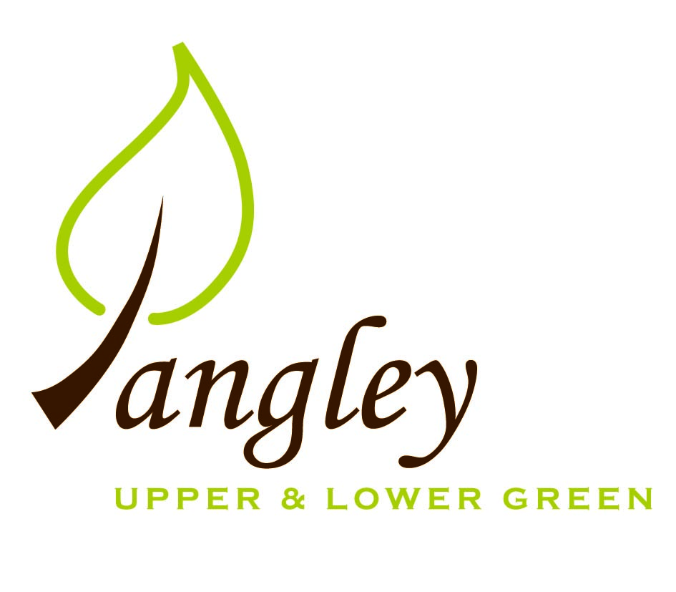
Langley Parish Council
Clerk: Erica Williams
13 Princes Close, Balsham, Cambridge CB21 4EE
07539 249852
langleyclerk@googlemail.com

PARISH COUNCIL NOTICE – 7th April 2020
PLEASE NOTE THAT DUE TO THE CORONAVIRUS OUTBREAK, ALL PARISH COUNCIL MEETINGS ARE SUSPENDED UNTIL FURTHER NOTICE
The Parish Council will continue to deal with only urgent matters and all other business will be resumed upon commencement of normal meetings.
Any Councillor questions/concerns and agreements are all being managed via email.
If any parishioner has a question they wish to ask the Council, please contact the Clerk, Chair or any Councillor via email and we will respond as soon as possible (contact details below).
Any actions or agreements reached will be published on the website and village noticeboard.
Thank you for your co-operation at this time.
Langley Parish Council

Clerk Erica Williams langleyclerk@googlemail.com
Chair Carol Elkington p.c.elkington@btinternet.com
Vice Chair Mike North mikenorth48@hotmail.com
Councillors Ben Bull ben@benbull.net
Barrie Barnes post@barriebarnes.plus.com
Ken Rivett kenrivett@aol.com
Sue Gaillard sue@gaillard.co.uk
Andy Clark andy@asclarkandsons.co.uk

