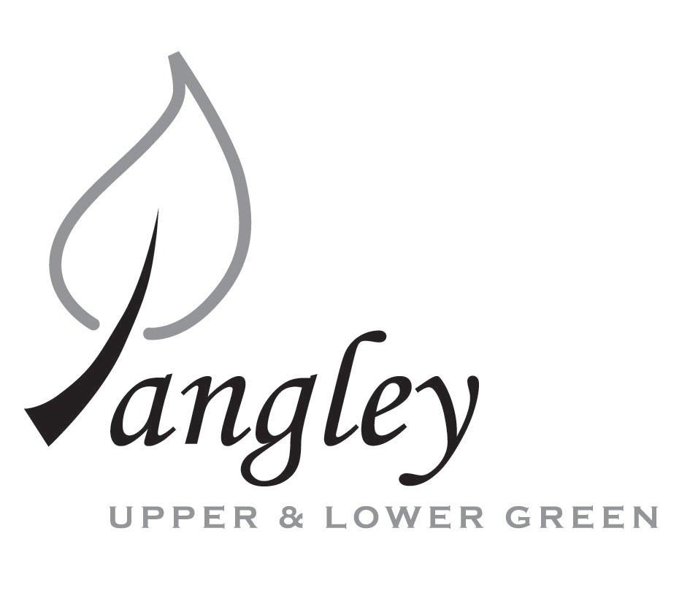
13 Princes Close, Balsham, Cambridgeshire CB21 4EE
E-mail: langleyclerk@googlemail.com
Telephone: 07539 249852

COUNCILLORS ARE SUMMONED TO ATTEND A MEETING OF LANGLEY PARISH COUNCIL
HELD AT LANGLEY COMMUNITY CENTRE ON
Monday 12th May 2025 at 8.00pm
THE PRESS AND THE PUBLIC ARE CORDIALLY INVITED TO ATTEND

This Parish Council supports the rights of anyone to record this meeting but advises that anyone so recording cannot disrupt the meeting, by means of the recording and expresses the hope that the person (or persons) carrying out the recording has obtained the necessary legal advice, for themselves, to ensure they understand the rights of any members of the public who may be present who do not wish to be filmed or recorded.

1. APOLOGIES FOR ABSENCE
1.1 To receive apologies for absence.

2. DECLARATION OF INTERESTS
2.1 To declare any disclosable pecuniary, other pecuniary or non-pecuniary interests relating to items on the agenda.

3. PUBLIC PARTICIPATION SESSION WITH RESPECT TO ITEMS ON THE AGENDA AND OTHER MATTERS THAT ARE OF MUTUAL INTEREST
3.1 The maximum time allowed for this item is 15 minutes. Members of the public who wish to comment on an Agenda item should do so at this point – maximum time allowed 5 minutes per Agenda item. Any questions raised shall not require a response at the meeting nor start a debate on the question. The Chair of the meeting may direct that a written or oral response be given.

4. MINUTES OF THE LAST MEETING
4.1 Councillors are asked to agree the Minutes of the Parish Council meeting held on Monday 14th April 2025, as a true and accurate account of the proceedings of the meetings.

5. FINANCIAL
5.1 Financial Report – Bank reconciliation as at 30th April, the current account balance was £22,150.18 (First precept payment received). PC unpresented payments, £945.12 resulting in a current account balance of £21,205.06. Broken down as follows: Playground H&S funds £239.37, Ditches funds £1,670.00, Speed sign funds £4,014.14; PC funds £15,281.55. PC deposit account £10,657.43.
5.2 Review of BACS payments.
5.3 Complaints policy
5.4 Councillor status
5.5 Quote for noticeboard maintenance
5.6 Grant from Hundred Parishes Society
5.7 Parish Council insurance
Items 5.8 – 5.16 Year End Accounts
5.8 Year-end accounts (ending 31st March 2025), including Bank Reconciliation, Receipts and Payments and Analysis of Variances to be approved by Council and signed by Chair.
5.9 Internal Control Statement for Year Ending 31st March 2025. To be approved by Council and signed by Chair.
5.10 Financial & Management Risk Assessment last reviewed in June 2024 to be reviewed again.
5.11 As neither the gross income nor gross expenditure exceeds £25,000 the PC are exempt from an external audit/limited assurance review;
5.12 Certificate of Exemption to be approved, dated and signed by RFO and Chair. Signed document to be submitted to PFK Littlejohns ASAP together with completed contact details form.
5.13 Status of Internal Audit to be reported to PC.
5.14 Council to review and approve by resolution the Annual Governance Statement 2024/2025 signed and dated by RFO and Chair.
5.15 Council to review and approve by resolution the Accounting Statements 2024/2025 signed and dated by RFO and Chair.
5.16 Copies of the following documents to be published on website on Monday 2nd June.
a) completed certificate of exemption;
b) completed, signed and dated annual internal audit report;
c) completed, approved, dated and signed annual governance statement;
d) completed, approved, dated and signed summary accounting statements;
e) analysis of variances
f) bank reconciliation;
g) notice of the period for the exercise of public rights; Dates set as Tuesday 3rd June to Monday 14th July. Notice to be published on website and noticeboards on Monday 2nd June.

6. PLANNING APPLICATIONS/PROPERTY
6.1 UTT/25/1021/FUL Duddenhoe Grange, Upper Green

7. LANGLEY VILLAGE PROJECT
7.1 Brief update from Village Project representatives.

8. LOCAL ENVIRONMENT
8.1 Grass cutting schedule and updates
8.2 Tree works update
8.3 Update on revised ditch clearance programme and flooding
8.4 Ponds
8.5 Flashing speed signs update
8.6 Long Ley update
8.7 Village of the Year award

9. PLAYGROUND
9.1 Maintenance schedule update

10. DISTRICT AND COUNTY COUNCIL
10.1 Cllr. Oliver to provide District Council report.

11. BACS PAYMENTS
11.1 Council to agree to the following BACS payments to be made:
Langley Parish Council – BACS payments for May 2025
Compact Contracting Services | Grass cutting | BACS | £552.85
Erica Williams | Clerks salary | BACS | £392.27
 |  | Total | £945.12

12. MATTERS TO BE RAISED BY MEMBERS FOR THE NEXT AGENDA
12.1 Please note that no decisions can lawfully be made under this item. LGA 1972, Section 12 10(2)(b) states that business must be specified; therefore, the Council cannot lawfully raise matters for decision.

13. DATE OF NEXT MEETINGS
13.1 The next meeting will be on Monday 9th June 2025 at Langley Community Centre.

SIGNED (CLERK): | DATE:

