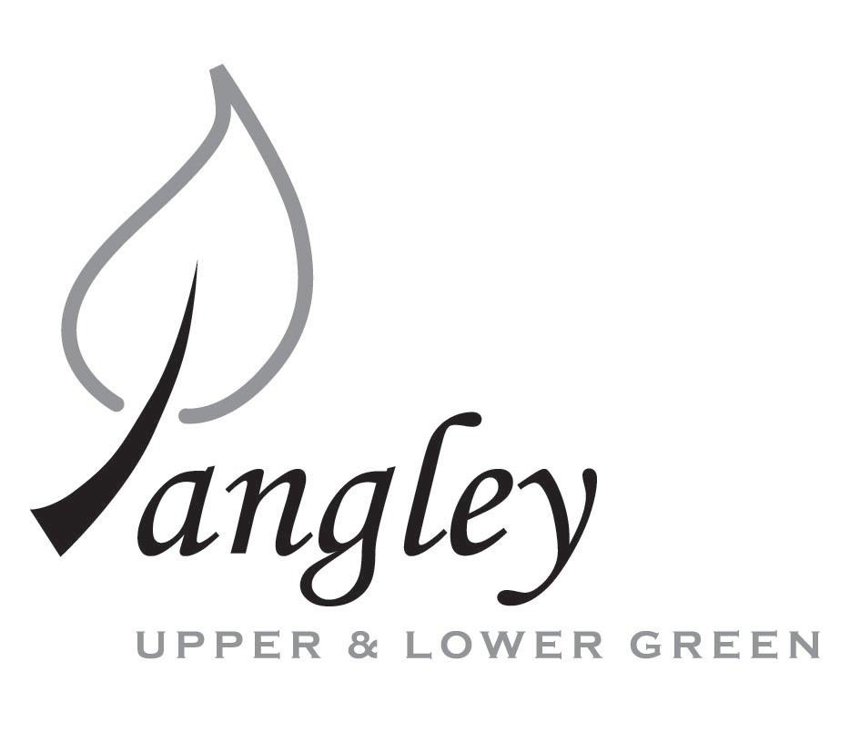
13 Princes Close, Balsham, Cambridgeshire CB21 4EE
E-mail: langleyclerk@googlemail.com
Telephone: 07539 249852

COUNCILLORS ARE SUMMONED TO ATTEND AN EXTRAORDINARY MEETING OF LANGLEY PARISH COUNCIL
HELD VIRTUALLY VIA ZOOM ON
MONDAY 10th August 2020 at 8.00pm
THE PRESS AND THE PUBLIC ARE CORDIALLY INVITED TO ATTEND – please email Clerk for log-in details

MEETING WILL BE RECORDED VIA ZOOM

AGENDA URGENT ITEMS ONLY
This Parish Council supports the rights of anyone to record this meeting but advises that anyone so recording cannot disrupt the meeting, by means of the recording and expresses the hope that the person (or persons) carrying out the recording has obtained the necessary legal advice, for themselves, to ensure they understand the rights of any members of the public who may be present who do not wish to be filmed or recorded.

1. APOLOGIES FOR ABSENCE
1.1 To receive apologies for absence.

2. DECLARATION OF INTERESTS
2.1 To declare any disclosable pecuniary, other pecuniary or non-pecuniary interests relating to items on the agenda.

3. PUBLIC PARTICIPATION SESSION WITH RESPECT TO ITEMS ON THE AGENDA AND OTHER MATTERS THAT ARE OF MUTUAL INTEREST
3.1 The maximum time allowed for this item is 15 minutes. Members of the public who wish to comment on an Agenda item should do so at this point – maximum time allowed 5 minutes per Agenda item. Any questions raised shall not require a response at the meeting nor start a debate on the question. The Chair of the meeting may direct that a written or oral response be given.

4. FINANCIAL
4.1 Financial Report – Bank reconciliation as at 23rd July, the current account balance was £11,886.22. PC unpresented cheques, £7,629.15 resulting in a current account balance of £4,257.07. Broken down as follows: Playground funds £1,230.48; Highways Devolution Project £1,000, PC funds £2,026.59. PC deposit account £13,149.56 – reserves unrestricted of £9,149.56 and reserves restricted (playground fund) of £4,000.
4.2 Review of Cheque Run

5. PLANNING APPLICATIONS
5.1 UTT/20/1746/HHF 4 The Kangels, Langley CB11 4SL
5.2 UTT/20/1872/FUL Rouen, Bull Lane, Langley CB11 4SA

6. LOCAL ENVIRONMENT
6.1 Collection of bins at the Community Centre

7. CHEQUES FOR SIGNING
7.1 Council to agree to the following cheques to be signed:
Langley Parish Council - Cheque run for August 2020
Sovereign Design Play Safety Ltd c/o CCC Finance | Installation of new play equipment |  | £6140.28
AC Dorren | Internal Audit |  | £120.00
Hundred Parishes Society | Membership Renewal |  | £10.00
Paul Abrahams | Grass Cutting |  | £350.00
Erica Williams | Clerks Salary |  | £321.07
 |  | Total: | £6,941.35

14. MATTERS TO BE RAISED BY MEMBERS FOR THE NEXT AGENDA
14.1 Please note that no decisions can lawfully be made under this item. LGA 1972, Section 12 10(2)(b) states that business must be specified; therefore, the Council cannot lawfully raise matters for decision.

15. DATE OF NEXT MEETINGS
15.1 The next meeting will be on Monday 14th September 2020.

SIGNED (CLERK): | DATE:

