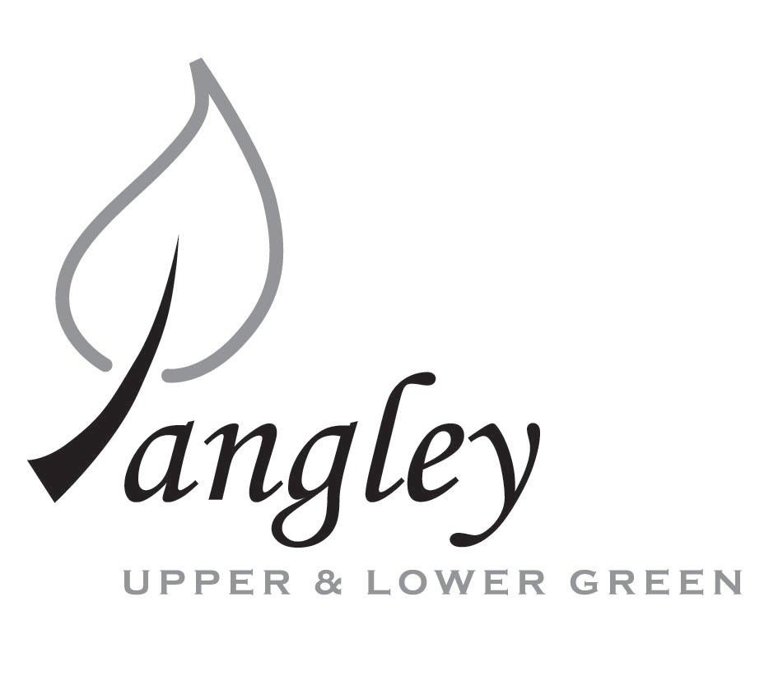
13 Princes Close, Balsham, Cambridgeshire CB21 4EE
E-mail: langleyclerk@googlemail.com
Telephone: 07539 249852

COUNCILLORS ARE SUMMONED TO ATTEND A MEETING OF LANGLEY PARISH COUNCIL
HELD AT LANGLEY COMMUNITY CENTRE, LANGLEY UPPER GREEN ON
MONDAY 10th February 2020 at 8.00pm
THE PRESS AND THE PUBLIC ARE CORDIALLY INVITED TO ATTEND

AGENDA
This Parish Council supports the rights of anyone to record this meeting but advises that anyone so recording cannot disrupt the meeting, by means of the recording and expresses the hope that the person (or persons) carrying out the recording has obtained the necessary legal advice, for themselves, to ensure they understand the rights of any members of the public who may be present who do not wish to be filmed or recorded.

1. APOLOGIES FOR ABSENCE
1.1 To receive apologies for absence.

2. DECLARATION OF INTERESTS
2.1 To declare any disclosable pecuniary, other pecuniary or non-pecuniary interests relating to items on the agenda.

3. PUBLIC PARTICIPATION SESSION WITH RESPECT TO ITEMS ON THE AGENDA AND OTHER MATTERS THAT ARE OF MUTUAL INTEREST
3.1 The maximum time allowed for this item is 15 minutes. Members of the public who wish to comment on an Agenda item should do so at this point – maximum time allowed 5 minutes per Agenda item. Any questions raised shall not require a response at the meeting nor start a debate on the question. The Chair of the meeting may direct that a written or oral response be given.

4. MINUTES OF THE LAST MEETING
4.1 Councilors are asked to agree the Minutes of the Parish Council meeting held on Monday 13th January, 2020 as a true and accurate account of the proceedings of the meetings.

5. GENERAL ADMINISTRATION
5.1 Clerks report to the Council
5.2 Clerks laptop to be serviced

6. FINANCIAL
6.1 Financial Report – Bank reconciliation as at 23rd January, the current account balance was £13,114.56. PC unpresented cheques, £1,334.48 resulting in a current account balance of £11,780.08 Broken down as follows: Playground funds £2,765.56; Highways Devolution Project £1,000, PC funds £8,014.52. PC deposit account £13,141.42 – reserves unrestricted of £9,141.42 and reserves restricted (playground fund) of £4,000.
6.2 Review of Cheque Run
6.3 Citizens Advice request for a donation
6.4 LCCC request for donation
6.5 Permission for Cllr Rivett to open an account to purchase posts & spikes for footpath waymarkers
6.6 Overdue invoice from Countryside Pest Control to be paid by the Community Centre

7. PLANNING APPLICATIONS/PROPERTY

7.1 UTT/20/0018/LB Wilbrook Langley Lower Green Langley CB11 4SB

7.2 UTT/20/0216/HHF Broad Halfpenny Upper Green Road Langley CB11 4RY

8. LANGLEY VILLAGE PROJECT
8.1 Update from Village Project representatives.

9. VILLAGE GREEN
9.1 Request to plant an additional tree on Village Green, outside The Brick House – update
9.2 Removal of lower branches from trees around village green.

10. LOCAL ENVIRONMENT
10.1 Electronic Parish Communication – mail regarding Bare Leaves Tree and Gardening Services
10.2 Withdrawl of Essex Infonet services – New Village website latest status
10.3 Uttlesford Association of Local Councils – any update?
10.4 Noticeboard refurbishment / Replacement noticeboard
10.5 Village Tidy: Pond at the Hoppers
10.6 Result of Cllr Rivett’s meeting with Highways re: Bull Lane – any further update?
10.7 Agreement to share Green Waste collection with Clavering PC

11. PLAYGROUND
11.1 Replacement of worn parts following inspection – has this been carried out yet?
11.2 Removal of concrete blocks – outstanding

12. DISTRICT AND COUNTY COUNCIL
12.1 Cllr. Oliver to provide District Council report.

13. CHEQUES FOR SIGNING
13.1 Council to agree to the following cheques to be signed:
Langley Parish Council - Cheque run for February 2020
Paul Abrahams | Grass Cutting | 101381 | £390.00
Paul Abrahams | Grass Cutting | 101382 | £30.00
Paul Abrahams | Grass Cutting | 101383 | £400.00
Langley Community Centre Sports Trust | Rent for use of Langley Community Centre | 101384 | £120.00
SLCC | Membership renewal | 101385 | £92.00
Erica Williams | Clerks Salary | 101386 | £302.48
 |  | Total: | £1,334.48

14. MATTERS TO BE RAISED BY MEMBERS FOR THE NEXT AGENDA
14.1 Please note that no decisions can lawfully be made under this item. LGA 1972, Section 12 10(2)(b) states that business must be specified; therefore, the Council cannot lawfully raise matters for decision.

15. DATE OF NEXT MEETINGS
15.1 The next meeting will be on Monday 9th March 2020.

SIGNED (CLERK): | DATE:

